**Assignment 11.3:**

**Create a flume agent that streams data from Twitter and stores in the HDFS.**

* Login to Twitter to create a twitter app and get the access code from the twitter.
* Add the required jars under Flume library

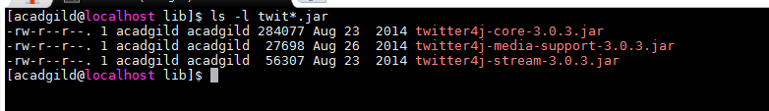

* Create Flume.conf file under conf folder in Flume Directory which has consumerkey, consumer secrete key and accesstoken.

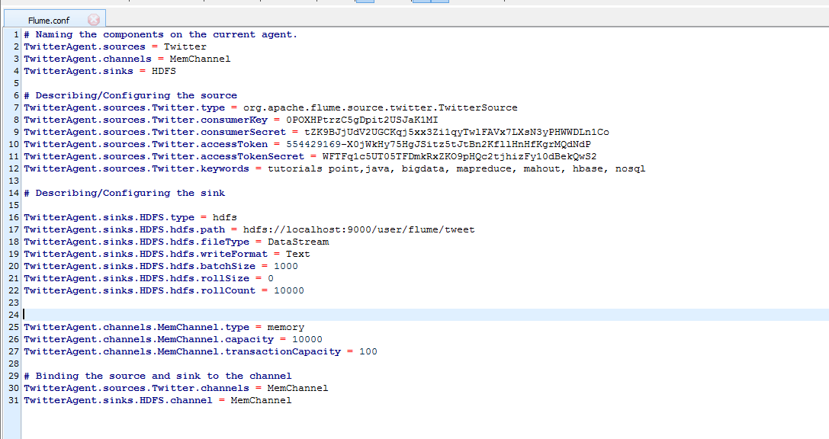

* Create a folder under hdfs as below:

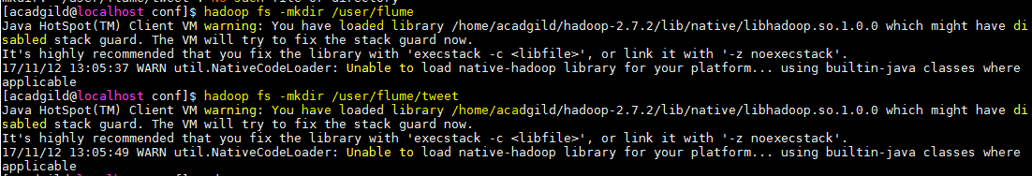

* **Invoke Flume agent by passing Flume.conf file.**

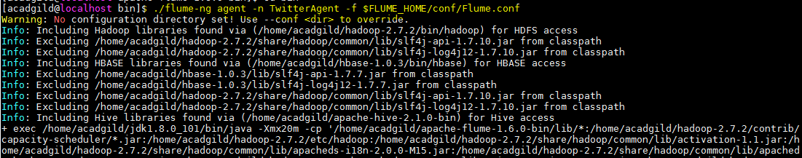

**Check the processed data.**

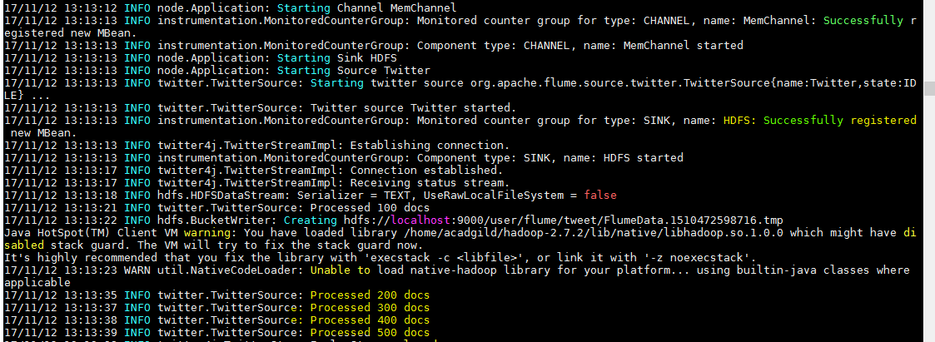

* **To check whether file containing tweet data got created successfully inside hdfs or not, used the following command:**

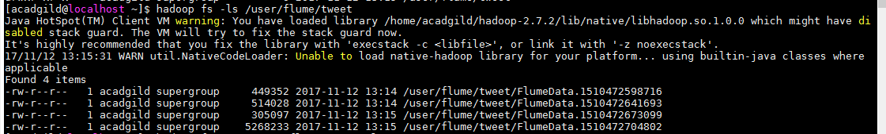

**Tweets :**

